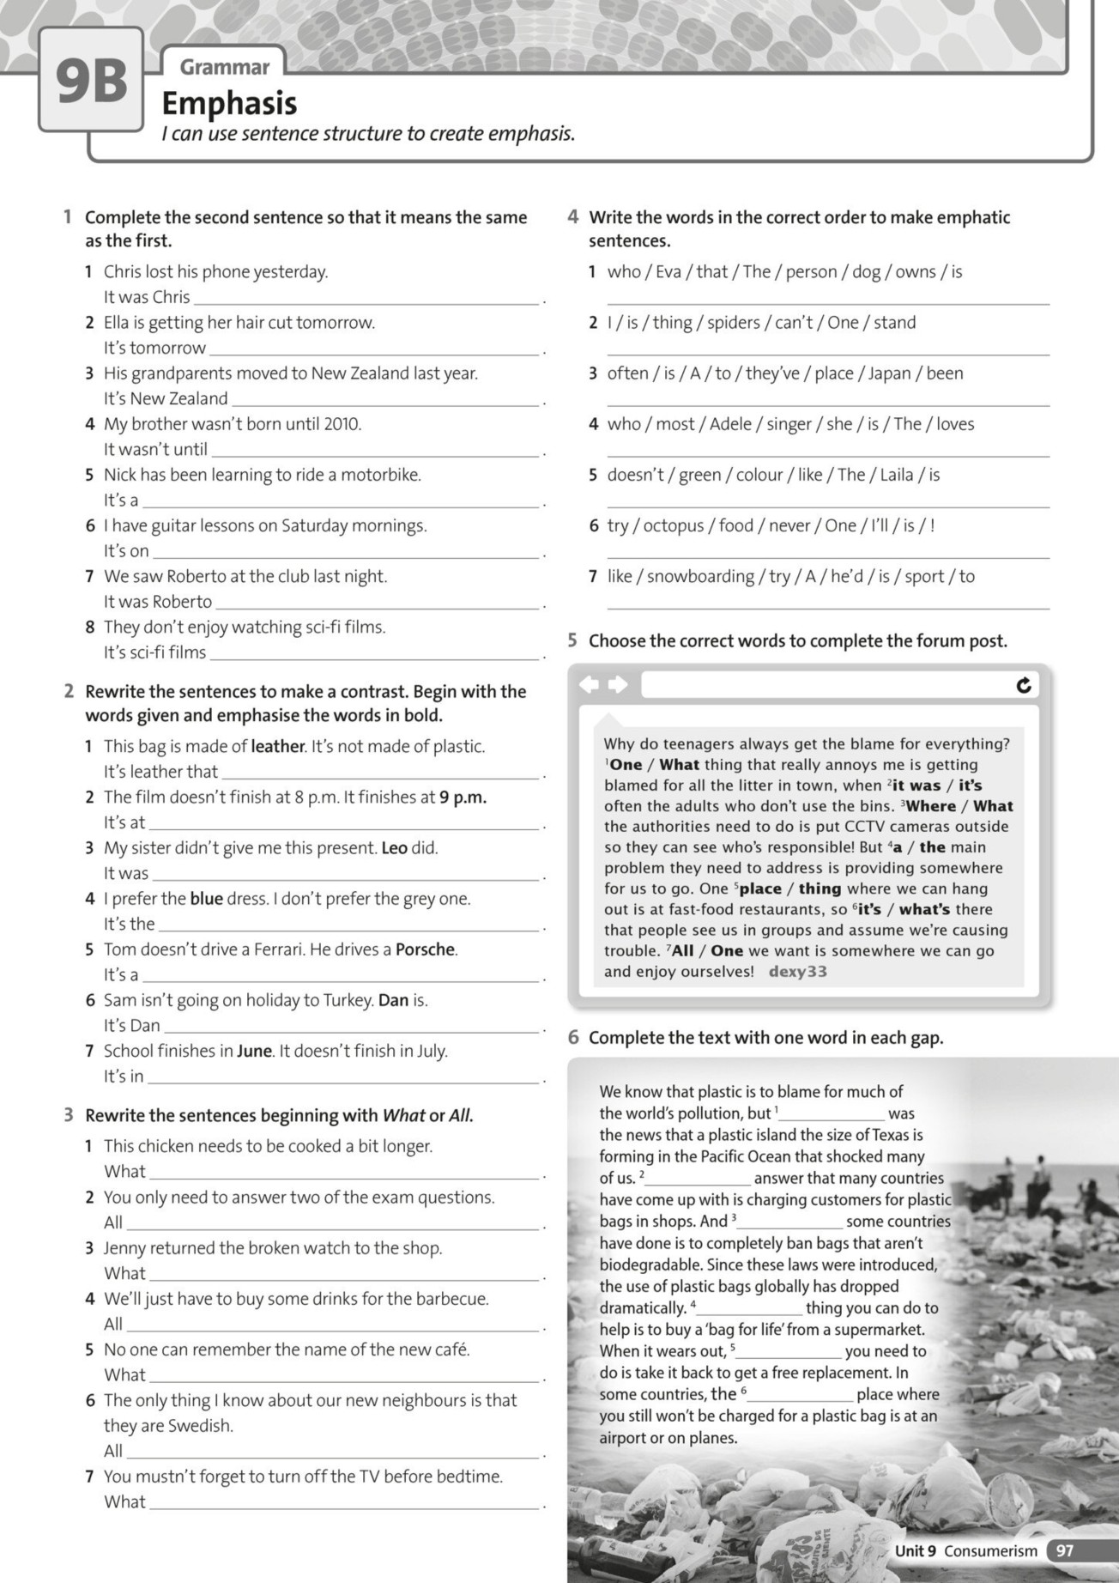
only
the
the
what
what
what
The person who owns that dog is Eva.
The one thing I can't stand is spiders.
It's often in Japan that they've been to a place.
The singer who most people love is Adele.
The colour Laila doesn't like is green.
The one food I'll never try is octopus!
The sport he'd like to try is snowboarding

this chicken needs is to be cooked a bit longer.
you need to do is answer two of the exam questions.
Jenny returned to the shop was the broken watch
we'll have to do is buy some drinks for the barbecue.
no one can remember is the name of the new cafe.
I know about our new neighbours is that they are Swedish.
you mustn't forget to do before bedtime is turn off the TV.

this bag is made of.
9 p.m. that the film finishes.
Leo who gave me this present.
blue dress that I prefer.
Porsche that Tom drives.
who is going on holiday to Turkey.
June that school finishes.

who lost his phone yesterday.
that Ella is getting her hair cut tomorrow.
who moved to New Zealand last year.
2010 that my brother was born
guitar that Nick has been learning to ride a motorbike.
Saturday mornings that I have guitar lessons.
that we saw at the club last night.
that they don’t enjoy watching.

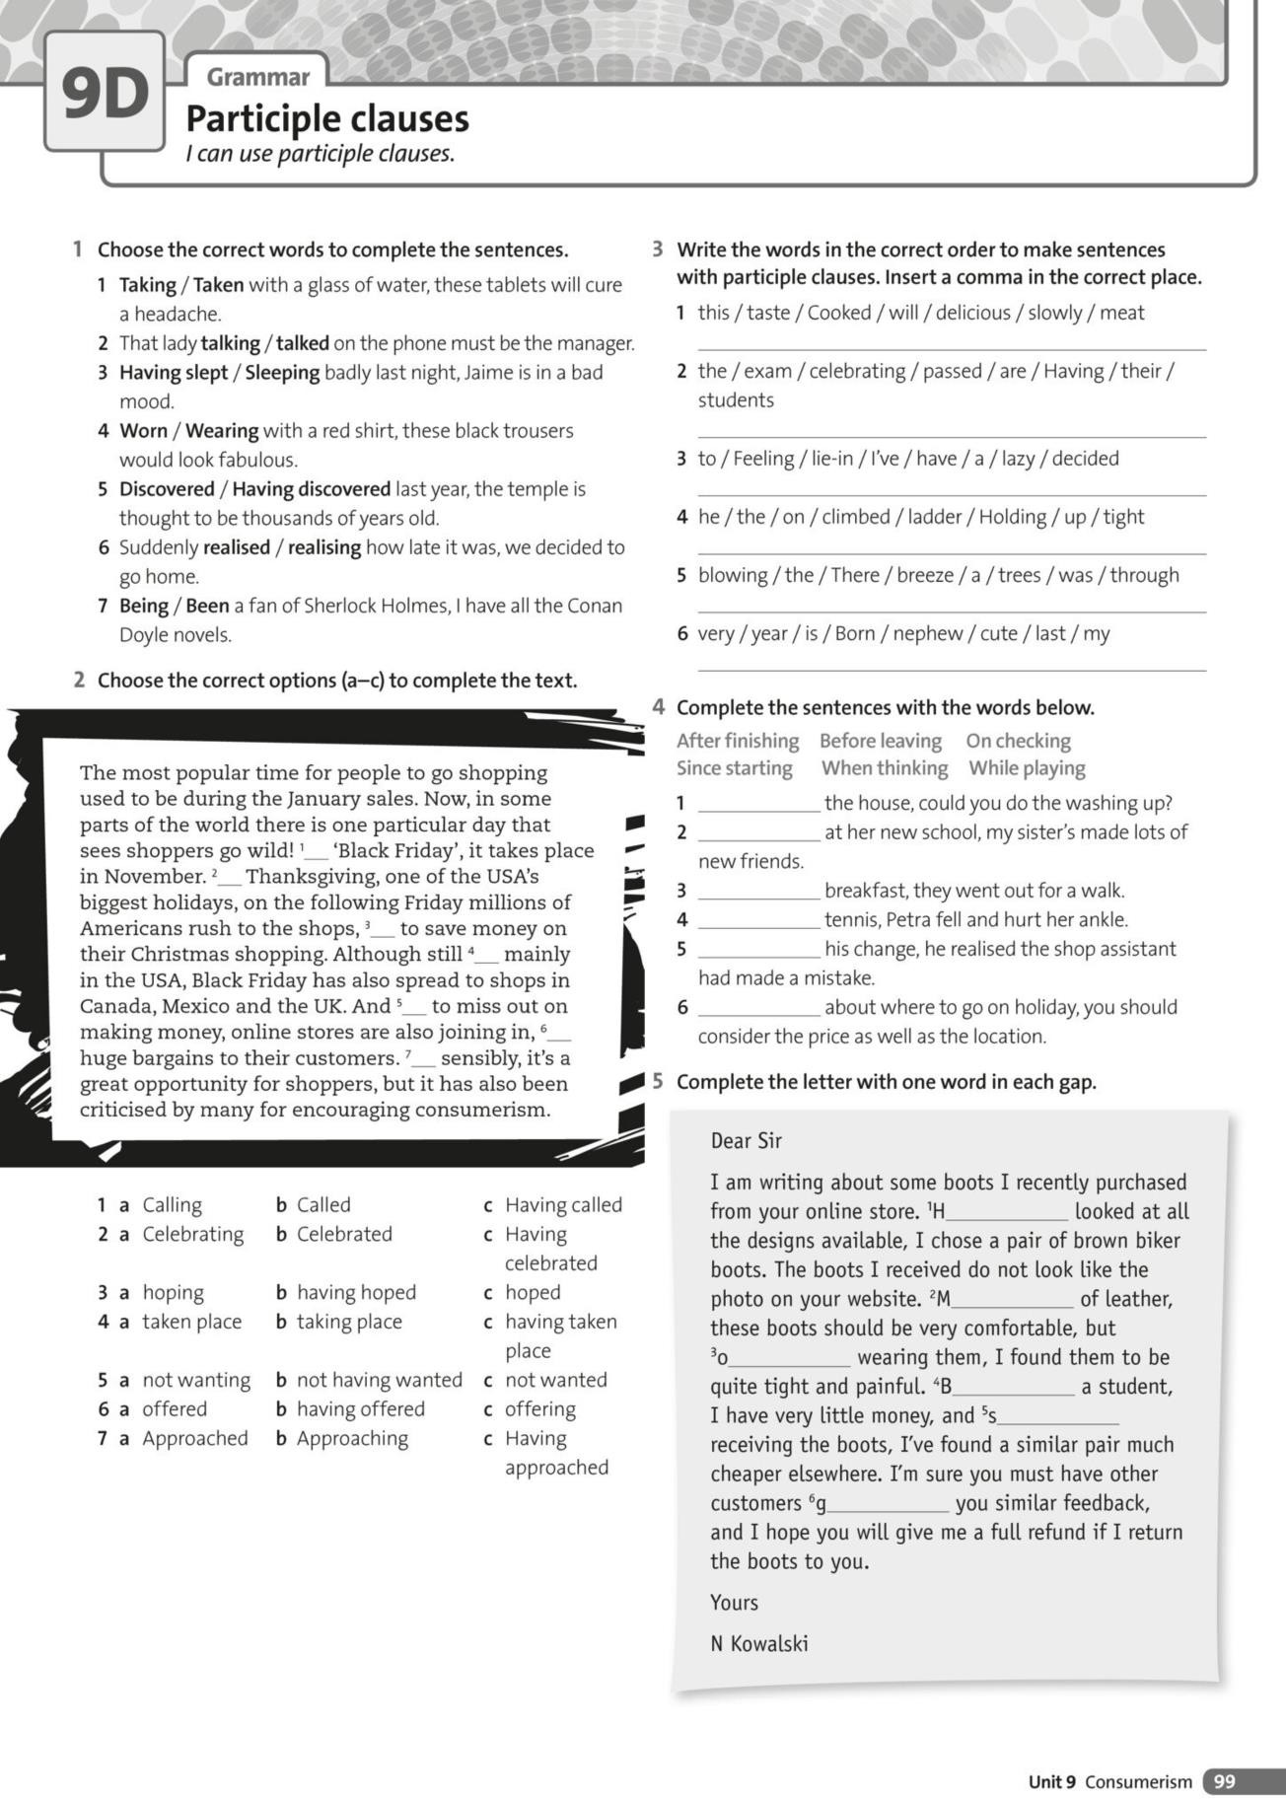
iving
ince
eing
n
ade
aving
1.After finishing
2.While playing
3.Before leaving
4.When checking
5.Since starting
6.After having found
Cooked slowly, this meat will taste delicious.
Having passed the exam, the students are celebrating their results.
Feeling lazy, I've decided to have a lie-in.
Holding tight onto the ladder, he climbed up.
There was a breeze blowing through the trees.
Born last year, my nephew is very cute.

